Functionality Specification Document

----------------------------------------------------------------------------------------------------------------------------

Document Version 1.0
2nd May 2021

Author: Jayanta Acharjee

  - How this Document is organized

This document is organized into the following chapters:

- Chapter 2 - "Introduction" provides solution scope to be delivered to our Client.

- Chapter 3 - "Flow Chart" explains the execution of flow of the App.

- Chapter 4 - "Sprint Planning" how the project was developed in each phase.

- Chapter 5 - "Solution Overview" provides how the solution of the project is.

- Chapter 6 - “GitHub link” provides the information on where the project is located.

Functionality Specification Quiz App Angular.pdf

Page 2 of 9

Functionality Specification Document Quiz App

1.2 Contact Information

Quiz App welcomes your comments and suggestions on the quality and usefulness of this document. For any questions, comments, or suggestions on the documentation, you can contact us at the following address:

For India Enquiry.

Jayanta Acharjee

Quiz App India

Tel: +91 7278121549

contact_us@quizapp

Functionality Specification Quiz App Angular.pdf

Page 3 of 9

Functionality Specification Document Quiz App


2. Introduction

This document describes the implementation of Quiz App and how its users can interact with the application.

Quiz App is a platform where we give exam.

2.1 Objectives

The objective of this document is to describe how the solution of Quiz App will integrate with the User.

This document also provides information on end-to-end workflow flow so that business users can understand the features and functionalities of the Quiz App.

The workflow mainly involves the following important aspects,

- Trivia API which is an API to generate random questions

- For every right answer given by the user they are awarded with 10 points and -5 for very wrong answers.

Functionality Specification Quiz App Angular.pdf

Page 4 of 9

Functionality Specification Document Quiz App


3. Flow chart

3.1 The objective of this session if to show how the user interacts with the user flow of the Quiz App

.
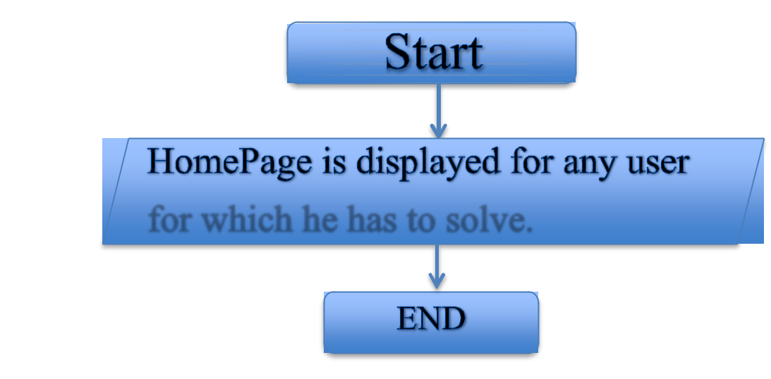

Functionality Specification Quiz App Angular.pdf

Page 5 of 9

Functionality Specification Document Quiz App


4. Sprint planning

4.1 This section tells how the workload was sliced into smaller part and was completed.

For effective pace and efficiency, a GitHub project board was managed as shown below. It was divided into three parts

- Open

- In Progress

- Completed in Sprint 1

The timebox for each sprint was 1 week.
Sprint 1

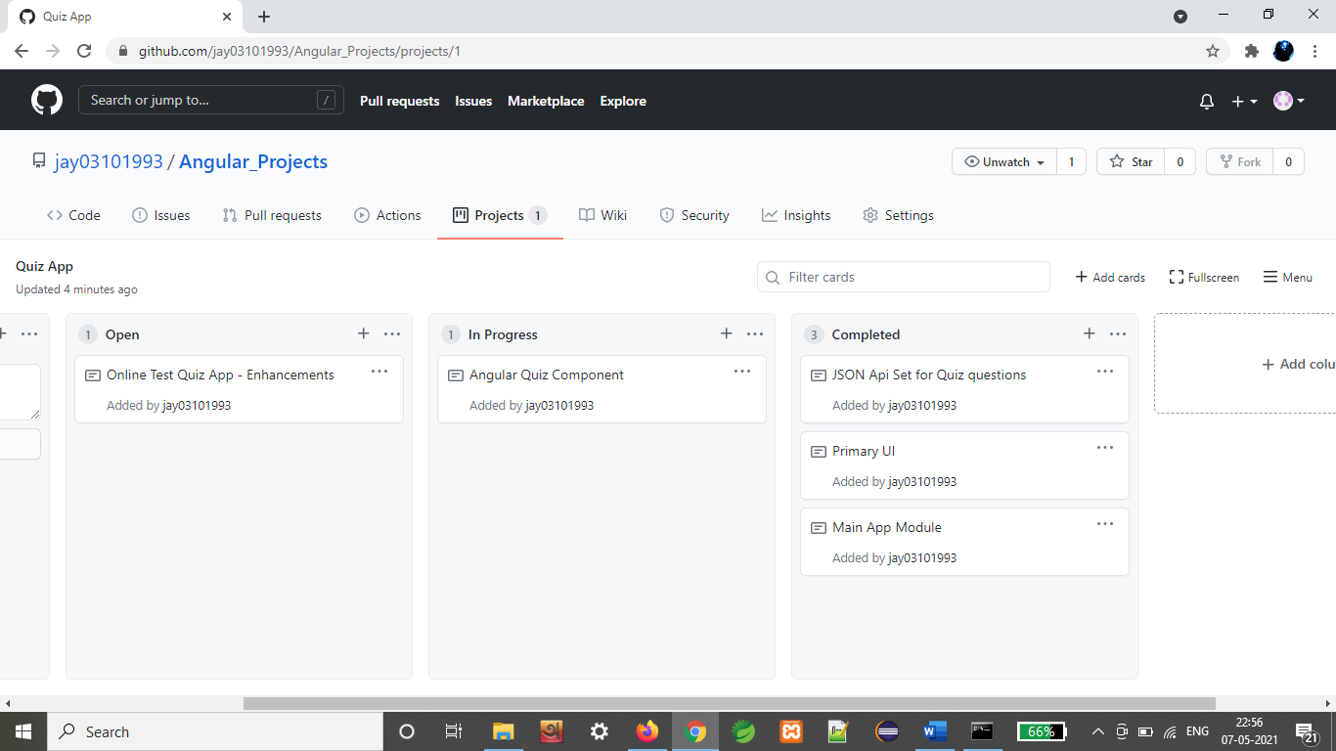
The complete activity of the sprint can be seen from the below link.

Click here: - https://github.com/jay03101993/Angular_Projects/projects/1

Functionality Specification Quiz App Angular.pdf

Page 6 of 9

Functionality Specification Document Quiz App


- Solution Overview

Platform requirement

The platform used for this project is the angular, node js, VS code.

5.1. UI for User: -

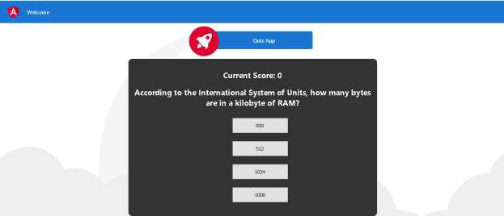
Below is the welcome page of the application =====================================================================

========================================================================

Step 1: - The above page is displayed for the user to solve the question and answers.

----------------------------------------------------------------------------------------------------------------------------

Functionality Specification Quiz App Angular.pdf

Page 7 of 9

Functionality Specification Document Quiz App
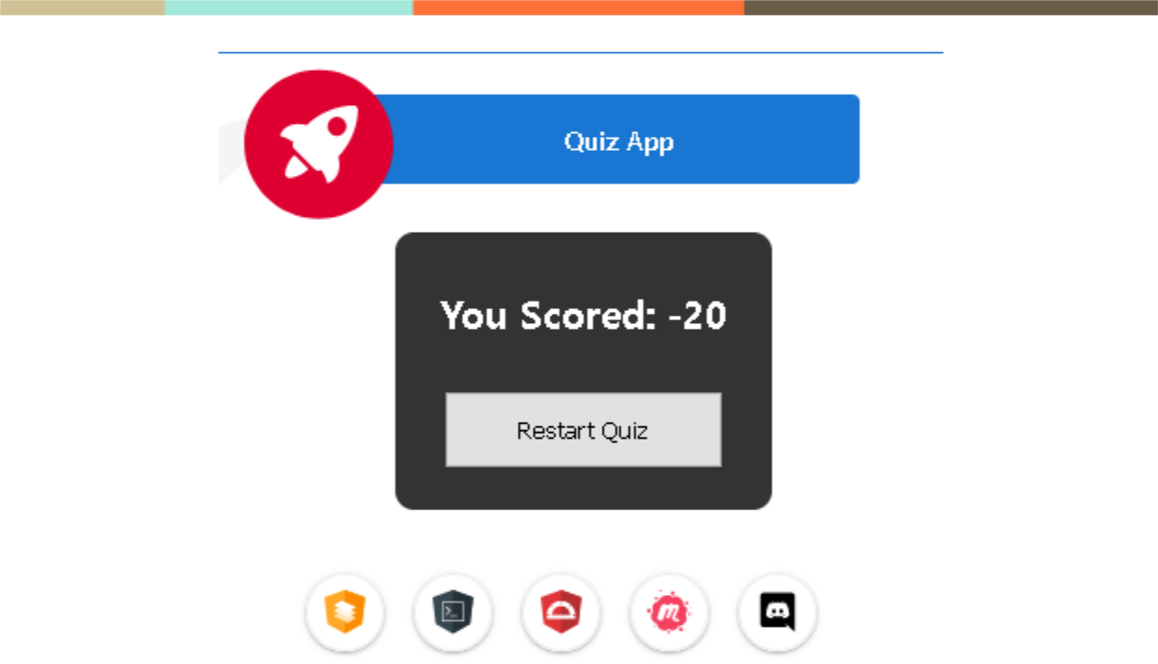

Step 2 - After completion of the quiz the following page is displayed. =====================================================================

.

Functionality Specification Quiz App Angular.pdf

Page 8 of 9

Functionality Specification Document Quiz App


- Github link

This section lists where the source code is located and from where the user can download and use it.

https://github.com/jay03101993/Angular_Projects

Functionality Specification Quiz App Angular.pdf

Page 9 of 9

